



C++ PROGRAMMING
(335)
STATE 2021

APPLICATION KNOWLEDGE:
Caesar Cipher (400 points)

TOTAL POINTS (400 points)

Test Time: 90 minutes

Caesar Cipher

One of the simplest methods of encryption is the Caesar cipher, also known as a shift cipher. It works on a simple premise – when each letter is shifted by a fixed amount, the resulting word is impossible to read unless that amount is known. In this exam, you will create a C++ console application that accepts a string input and an amount to shift, then shows the encrypted string. To show that it isn’t random, the encrypted string is then shown decrypted, and it should match what was input.

To simplify the encryption, the shift should be limited to a value between 1 and 5, and to prevent issues with this shift input validation should be looped until a value is properly entered.

Additionally, a Cipher class should be created to facilitate the encryption and decryption of input using the Caesar shift. Case-sensitivity should also be preserved during encryption and decryption. Note that when decrypting a value encrypted using a Caesar cipher, the process of decryption is identical to encryption but with a reversed shift.

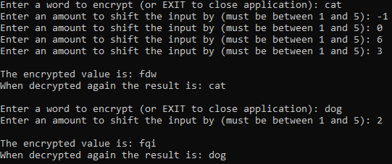

Figure 1: Sample output for input cat and dog with shifts of 3 and 2,
showing sample input validation.

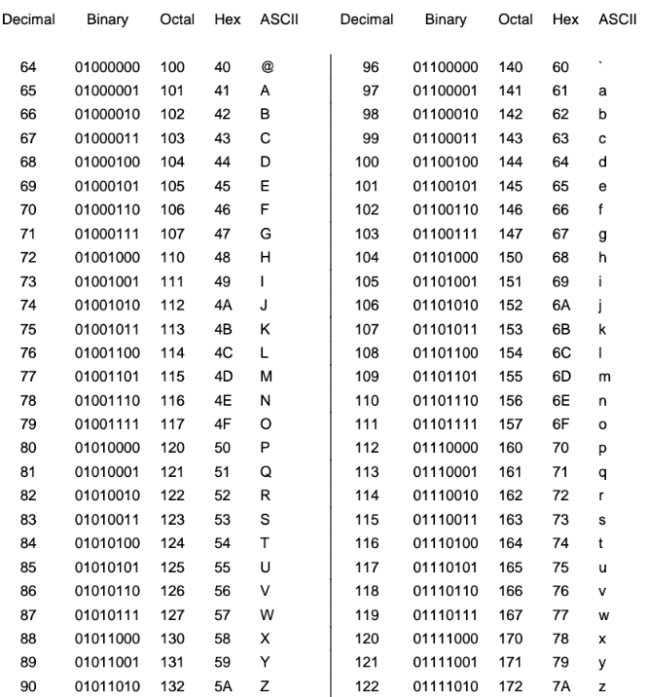

Figure 2: An Ascii table that can be used for performing the necessary shift.

Requirements:
- You must create a C++ console application named CPP_335_ContestantNumber, where ContestantNumber is your BPA assigned contestant number (including dashes). For example, CPP_335_01_2345_6789.
- Your contestant number must appear as a comment at the top of the main source code file.
- A Cipher class shall be implemented to facilitate the Caesar shift operations and must support both encryption and decryption operations.
- If the target word to encrypt is EXIT, the application shall stop looping and instead prompt for the user to press a key to exit the application.
- Otherwise, the application shall continuously prompt for a word to encrypt, a number to shift by, and then report the encrypted and then decrypted word, until EXIT is entered.
- When entering the shift amount, the application shall continuously ask for additional input until amount is between 1 and 5.
Your application will be scored on the following criteria:

Solution and Project

The project is present on the flash drive ____ 10 pts
The project is named according to the naming conventions ____ 10 pts

Program Execution

Code copied to flash drive and the program runs from the flash drive ____ 10 pts

If the program does not execute, then the remaining items in this section receive a score of zero.

Application prompts user for a word to encrypt ____ 20 pts
Application prompts user for an amount to shift by ____ 20 pts
Application performs proper validation for amount to shift by ____ 35 pts
Application performs proper Caesar cipher according to specification ____ 50 pts
Caesar cipher properly preserves case sensitivity ____ 50 pts
Application repeats until EXIT is entered as word to encrypt ____ 20 pts
Application pauses prior to exiting ____ 20 pts

Source Code Review

Code is commented at the top, for each function, and as needed ____ 20 pts
Code uses reasonable and consistent variable naming conventions ____ 20 pts
Cipher class exists and has suitable functions and constructors ____ 50 pts
Cipher functions are reasonably modular in design ____ 35 pts
Input validation is performed properly ____ 30 pts

Total Points: ____ 400 pts

Sample Output for Verification
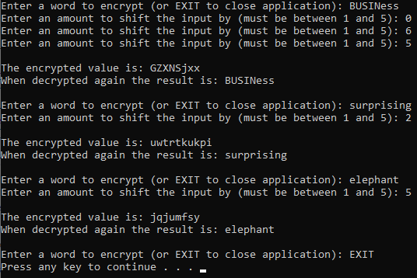
Completed Source Code
#include <iostream>
#include <fstream>
#include <string>

using namespace std;

class Cipher
{
private:

string input;

public:

Cipher()
{

}

Cipher(string newInput)
{
SetInput(newInput);
}

void SetInput(string newInput)
{
input = newInput;
}

string Encrypt(int shift)
{
char ch;
string result = "";

for (int i = 0; i < input.length(); i++)
{
ch = input[i];
if (isalpha(ch))
{
if (isupper(ch))
{
ch += shift;
if (ch > 'Z')
ch += 'A' - 1 - 'Z';
result += char(ch);
}
else
{
ch += shift;
if (ch > 'z')
ch += 'a' - 1 - 'z';
result += char(ch);
}
}
}

return result;
}

string Decrypt(int shift)
{
char ch;
string result = "";

for (int i = 0; i < input.length(); i++)
{
ch = input[i];
if (isalpha(ch))
{
if (isupper(ch))
{
ch -= shift;
if (ch < 'A')
ch -= 'A' - 1 - 'Z';
result += char(ch);
}
else
{
ch -= shift;
if (ch < 'a')
ch -= 'a' - 1 - 'z';
result += char(ch);
}
}
}

return result;
}
};

int main()
{
string input;
string encryptedVal;
string decryptedVal;
bool running = true;
int shiftCnt = 0;

while (running)
{
cout << "Enter a word to encrypt (or EXIT to close application): ";
getline(cin, input);

if (!input.compare("EXIT"))
{
running = false;
}
else
{
Cipher enc(input);
Cipher dec;

do
{
cout << "Enter an amount to shift the input by (must be between 1 and 5): ";
getline(cin, input);
shiftCnt = atoi(input.c_str());
} while (shiftCnt > 5 || shiftCnt < 1);

encryptedVal = enc.Encrypt(shiftCnt);
dec.SetInput(encryptedVal);
decryptedVal = dec.Decrypt(shiftCnt);

cout << "\nThe encrypted value is: " << encryptedVal << endl;
cout << "When decrypted again the result is: " << decryptedVal << endl << endl;
}
}

system("pause");
return 0;
}

